Project 1 – Milestone 1

For project 1 I want to recreate and advance my project 2 from last semester. I really like how my project came out last semester and I want to take it a step forward. To refresh my project 2 last semester was a money counter app. I’ll include a couple pictures below:

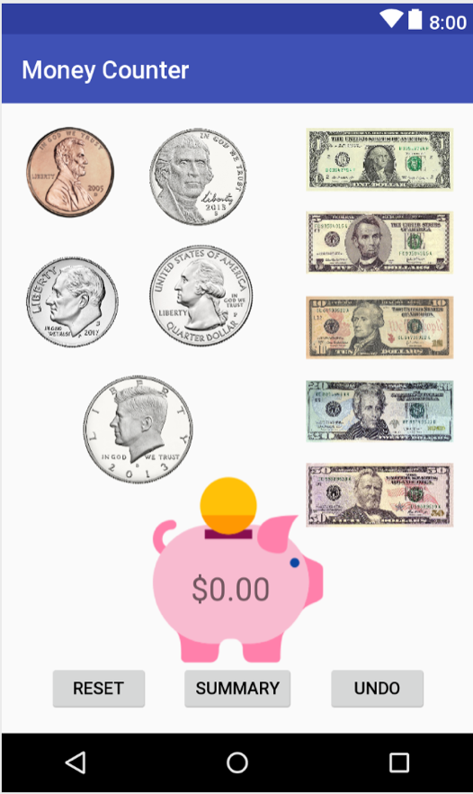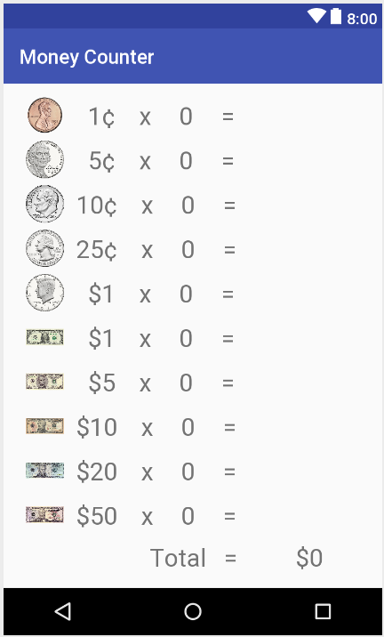

For the first view of my new app I want to have the money counter page and for the second view I want to have the money totals page. I also want to include a third view with another function. I was thinking of including a save function so you can store past amounts and add to them later on or just keep them for reference in a list view. This would require me to make the data persistent when the app is closed and persistent between each view. I might have a limited number of saves you can make, like three if this app becomes too complicated.